Naincy Thapa

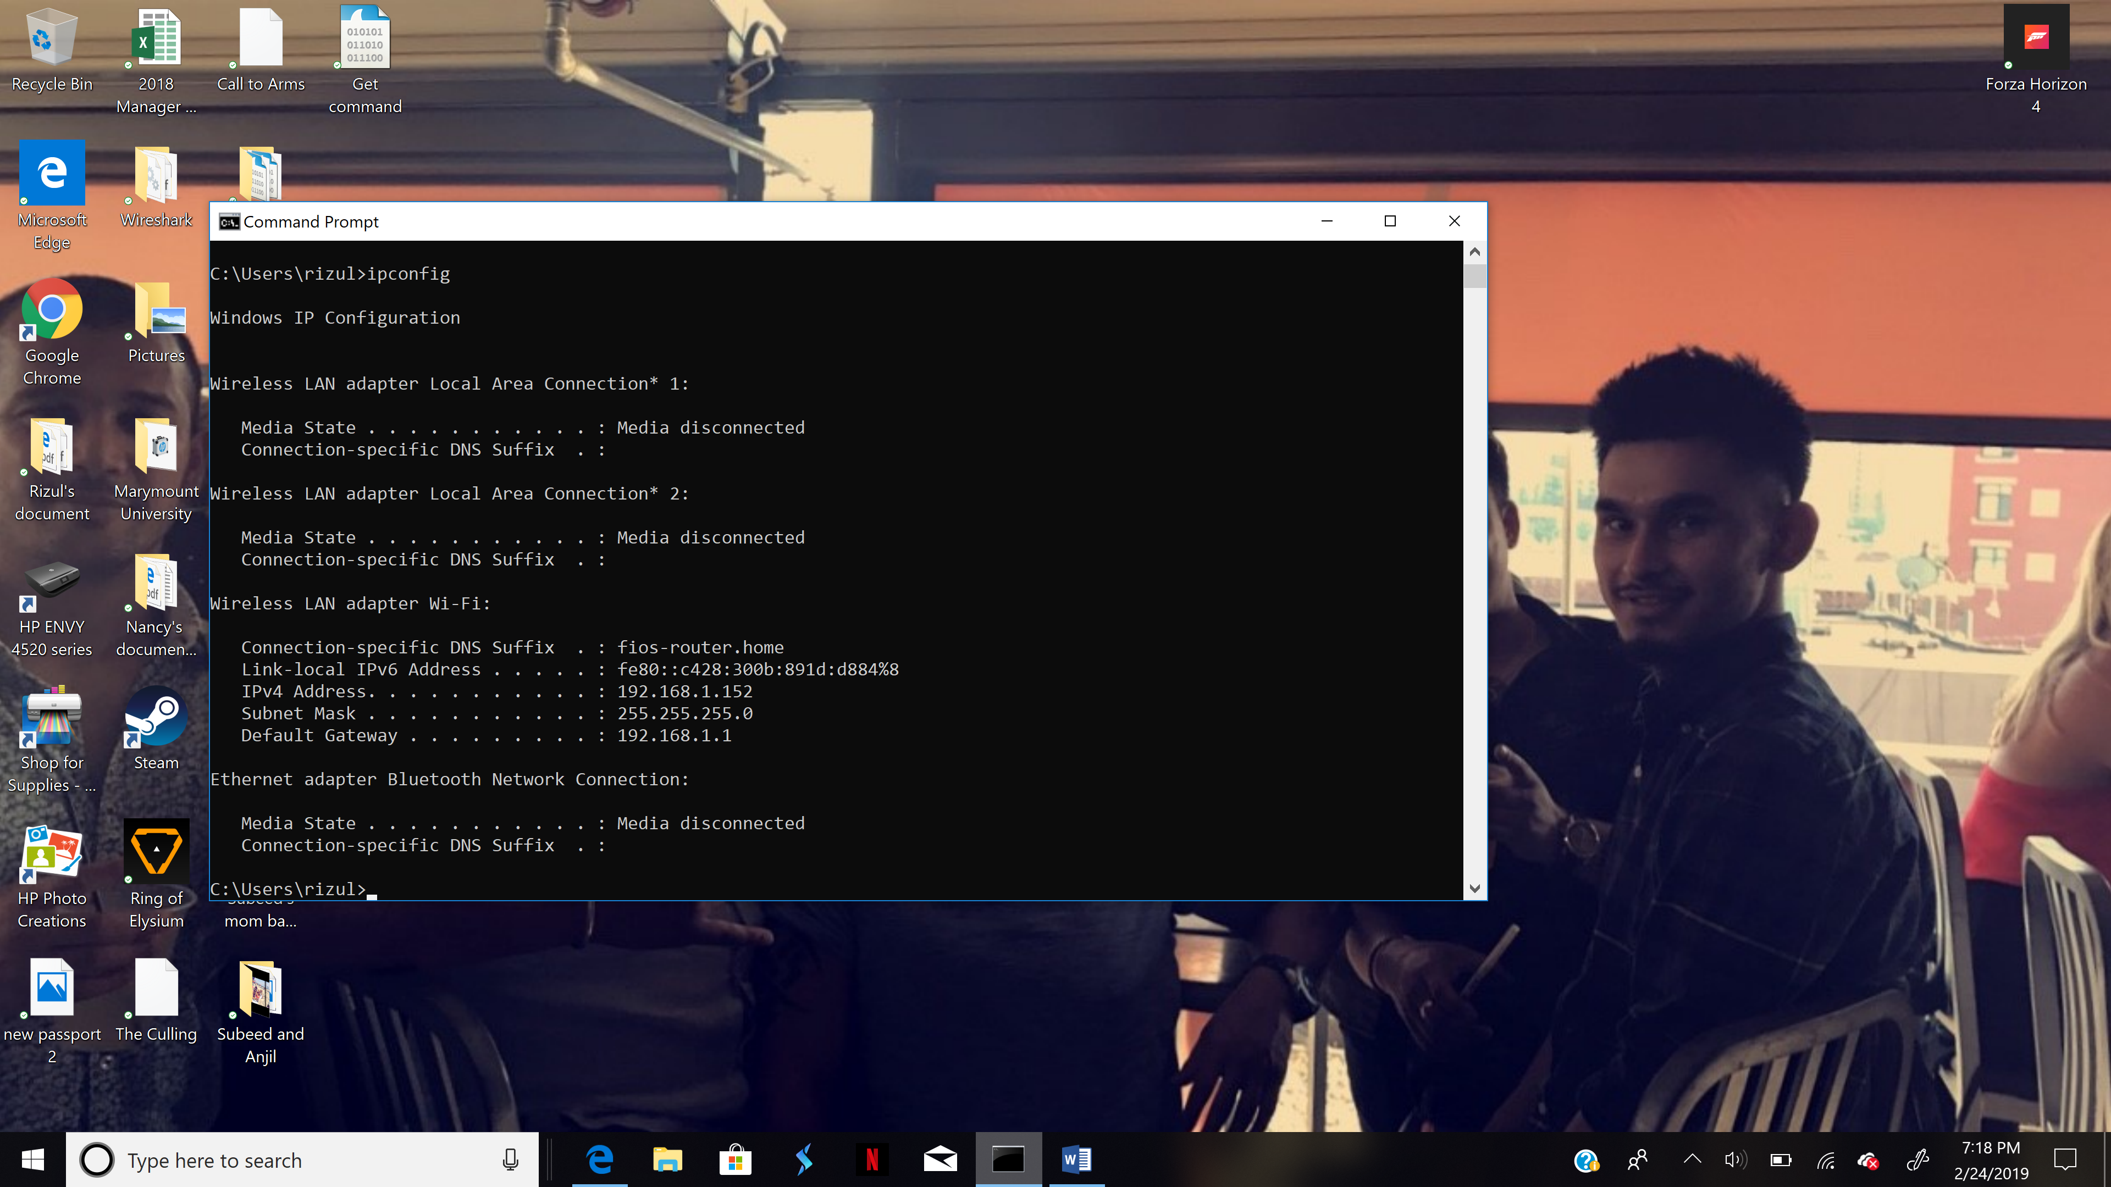

1. What is the IP address of your computer? – **Wireshark screenshot not, Terminal**

2. What is the total length of the datagram?

3. Has this IP datagram been fragmented?

4. How many bytes are in the IP header?

5. How many bytes are in the payload of the IP datagram? **Explain how you determined the number of payload bytes.**